My initial understanding from the documents is, that

DUAM is a User Creation and Access and Resource Management Tool and

there are two parts of the DUAM application.

1. WEBDUAM
2. WINDUAM

Roles and Responsibilities of WebDUAM:

In WebDuam we can

1. Create a user
2. Update a user
3. Delete a user

**We can also create new users in bulk:**

* + - Through a SOP file, its just an excel file template where user data needs to be filled.
    - This upload tool only used by us. Still some bugs in the tool.

There is also Cost Center Department. When a user is created they are assigned to a cost center.

The manager of the cost center apply’s pre-defined profiles with resources, for a new user.

We also have a WEBDUAM dashboard which shows workflows and open red tasks which have been sent to approvers for resource right request.

The other part is WinDUAM.

WinDuam is a configuration and management Tool that configures the data needed in DUAM (managing resources, assigning owners,…) and also , linking resources and synching them.

The other parts of this application are: ----

1. Active directory management
2. Data Viewers
3. A Reporting tool is also available in WinDuam.

So in WinDUAM we create new resources like :

**Resource types**: Application, Shared Folder, Database, Printer, Active Directory group, System.

**Resource Owner** (mandatory – 2 persons): person who is responsible for approving access to the application.

Profiles: need to understand more about this topic.

DUAM Dashboard

Can be used to search for historical information on workflows.

Filters can also be used based on Workflow type, data and work flow state.

State can be---- open, closed , all.

Synchronization of accesses :

Synchronization between the access rights granted in DUAM and the accesses to the applications

By linking a resource to an active Directory group.

DataViewers : which are used to check the existence of user in Active Directory.

Reporting Tool :

Aura Upload Tool Winduam

Constants Generator Tool : Used for simple code generation

Technical Side:

DUAM is integrated with other applications at database, service and Active Directory level.

**WEBSERVICES:**

DUAM has implemented multiple Webservices like

1. Identity Webservice, which is also used by external applications, to implement Authentication.
2. **ADWEB is a webservice to integrate with Active Directory.**
3. **Facade Webservice its an inerface for different layers.**

**WEBDUAM contains two databases :**

1. Corporate_WhoIsWho
2. Corporate_Flows

Corporate_WhoIsWho database, data is populated from external two databases

1. SAP_IMDB
2. WhoisWho

Using the SSIS , which extracts data from these two database and loads into the DUAM DB.

**Application Platform**

Windows 7

Skills required:

C#.net

Vb.Net

Asp.net

WinForms

SSIS Package

Windows workflow foundation

Webservice

SQL Server.

**Source Code Control**

Path for the source control in TFS is shown in below diagram.

Project name: ITHR_DUAM

In software terms, Facade pattern hides the complexities of the systems and provides a simple interface to the clients.

This pattern involves one wrapper class which contains a set of methods available for the client. This pattern is particularly used when a system is very complex or difficult to understand and when the system has multiple subsystems.

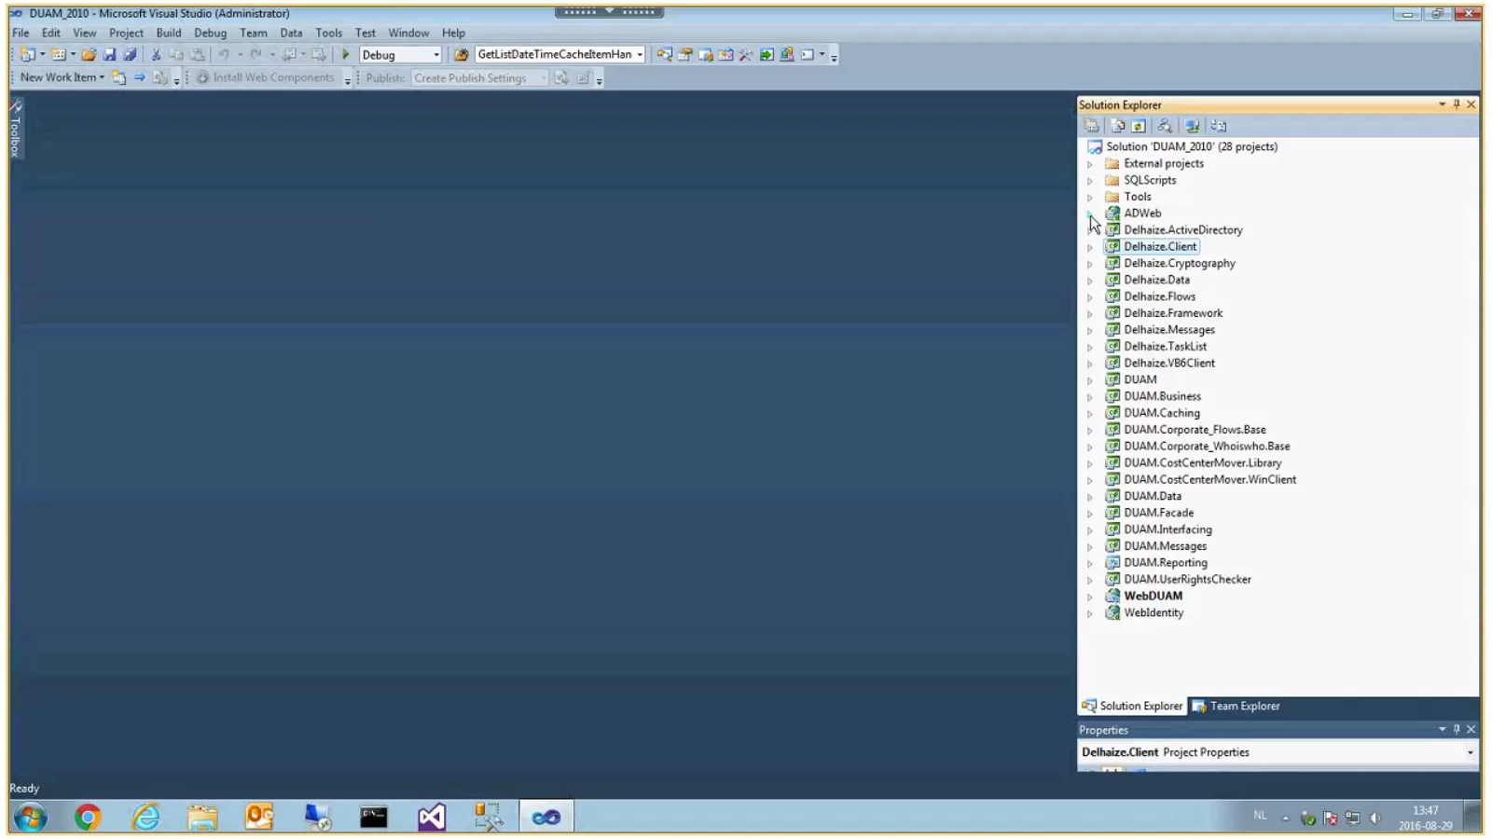

ADWeb

project directly interacts with active directory